I really wanted to make my own 8x8 LED display from stratch so I just ordered off of amazon a bunch of cheap red LEDS and some 500 ohm resistors.

I don’t have 64 outputs on my Arduino tho so I found these videos where they used a 74HC595 chip using clock/latch/data to make several output from those three using a library he made that.  
<https://www.youtube.com/watch?v=cAT07gy4DII>

<https://www.youtube.com/watch?v=RjzmKYg66nM>

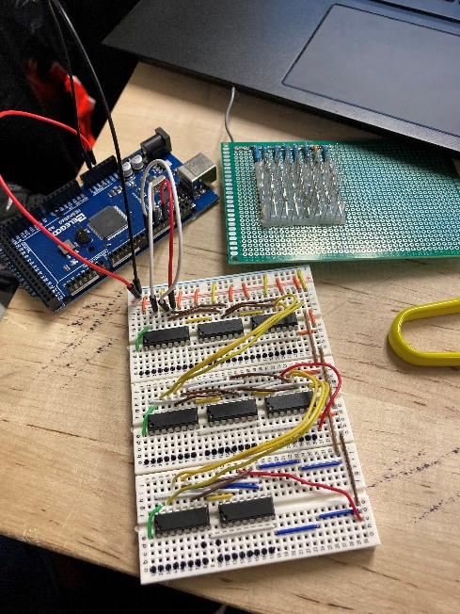

The original circuit I made with 8 chips did not work so I had to remake it and each connection form the board to the LEDs have a long collection of wires so putting it all together was more time consumping them id like to admit and somehow my sauntering got fucked up and I need to redo them but it is only the second to last row and the first two leds on the last row btu the rest of that row works so I know my program and circuit is actually correct. I am literally going to destroy this with hot glue after it works again so this wont happen in the future and throw me off.

